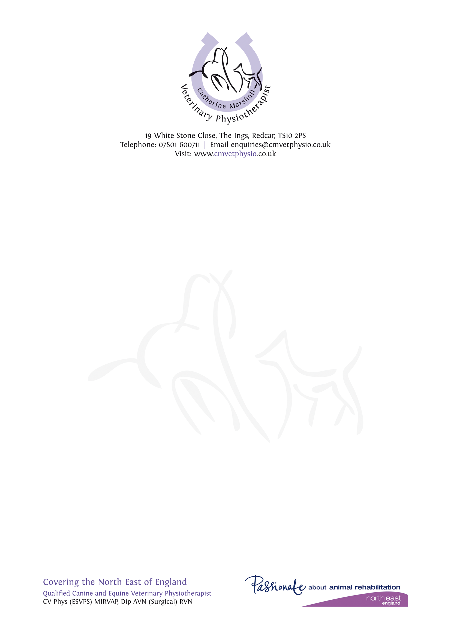

Veterinary Physiotherapy Consent Form

Owner’s Details

|  |  |
| --- | --- |
| Name: |  |
| Address: |  |
| Telephone: |  |
| Email: |  |

Animal’s Details

|  |  |  |  |
| --- | --- | --- | --- |
| Name: |  | | |
| Age: |  | Sex: |  |
| Breed: |  | Colour: |  |

Medical History

|  |  |
| --- | --- |
| Diagnosis  Current Medication  Investigation  Pre-existing conditions |  |

I consent to this animal having a physiotherapy assessment and appropriate treatment. I understand that the provision of professional indemnity insurance for this is the responsibility of Catherine Marshall.

|  |  |  |  |
| --- | --- | --- | --- |
| Practice:  Name & Address |  | | |
| Telephone: |  | | |
| Email: |  | | |
| Vets Name (print): |  | | |
| Vets Signature: |  | Date: |  |